Virginia Potato Disease Advisory – 2009
Sponsored by the Virginia Irish Potato Board
June11 – June 17

This is the ninth Virginia Potato Disease Advisory for 2009. We want to thank the Virginia Irish Potato Board for funding the network of sensors and our weekly reports. Thanks to the VIPB and all the participating producers! It is our goal to make the Advisory more informative this year than in years past by highlighting important potato diseases or pertinent subject matters with each report. See below for a description of late blight of potato. As always, your feedback is important and welcomed on how to make the VPDA more informative and effective.

Late Blight Disease Severity Values (DSV) and Early Blight P-Days continue to accumulate at all locations. See below for fungicide recommendations.

Late Blight Prediction: Fungicide applications should be initiated once 18 DSV’s have been accumulated for late blight. The threshold for late blight has been reached at all locations. Late blight continues to be found sporadically on the Eastern Shore of Virginia on both potato and tomato. If you have this disease present in your field and have some time remaining before vine kill, please make applications of fungicides targeting late blight. We also have seen several other diseases such as early blight, Botrytis blight and southern blight. Growers near the late blight discovery in Pocomoke should consider applying materials specific to late blight (such as Curzate, Previcur, Gavel, Revus Top, Ranman or Tanos). Ridomil Gold formulations MAY have some impact on the disease, but, strains of late blight that are resistant to this chemical have been reported in the past. Keep in mind that you need to include either a protectant or systemic material to protect against other diseases. At other locations, it advised to make a fungicide application targeting other diseases unless you are nearing vine kill. Growers may want to consider including a late blight material in their mixture as well. If you suspect late blight is present in your fields, please let us know. If you have any other questions, feel free to contact me. I will issue another update/report early next week. If rainy conditions continue, a 5-7 day spray schedule may be necessary to keep late blight from infecting your potatoes. I want to thank everyone for their diligent scouting this week and for assisting us in determining the magnitude of this current threat. Our current weather report calls for rainfall throughout next week, so please check for additional alerts or updates.

Early Blight Prediction: We use the program WISDOM to calculate P-Days, fungicide applications targeting early blight should be made when we reach 300 cumulative P-Days. We have reached this threshold at all locations. Maintaining a protectant or systemic material in your spray program that targets early blight is advised.

Late Blight Disease Severity Values (DSV) accumulated to date:

Location | Total DSV | Spray Recommendation
Horntown | 117 | SPRAY RECOMMENDED
New Church | 150 | SPRAY RECOMMENDED
Painter | 67 | SPRAY RECOMMENDED
Birdsnest | 70 | SPRAY RECOMMENDED
Seaview | 50 | SPRAY RECOMMENDED
Kiptopeke | 53 | SPRAY RECOMMENDED

Early Blight P-Days accumulated to date:
Location | Total P-Days | Spray Recommendation
Horntown | 531 | Spray Recommended
New Church | 529 | Spray Recommended
Painter | 552 | Spray Recommended
Birdsnest | 582 | Spray Recommended
Seaview | 534 | Spray Recommended
Kiptopeke | 536 | Spray Recommended

Weekly Potato Disease Summary
Late Blight of Potato
Causal Organism: Late blight of potato is caused by the airborne fungus (Oomycete) Phytophthora infestans. Late blight of potato is sporadic on the Eastern Shore of Virginia, but can be devastating if conditions favoring the disease persist. Trace amounts of late blight were observed on the Eastern Shore in 2006 and 2008, but the last significant outbreak was in 1996. Disease is favored by moderate temperatures (60-80F) with excessive rainfall or dews leading to high leaf moisture. Also of note, late blight of potato was the disease that caused the Irish Potato Famine in the 1840’s which led to the immigration or death of over 3 million Irish. The late blight pathogen can also parasitize tomatoes.

Symptomology: Infected potato leaves show ‘greasy’ lesions that usually originate from the tip of the leaves (Figure 1). During periods of high moisture gray sporulation can be seen on infected leaves. If infection persists or becomes systemic, tubers may become discolored exhibiting black and greasy lesions (Figure 2). Infected tubers may also transmit the disease to subsequent crops if they are used as seed pieces. In severe infections, complete defoliation can occur if appropriate disease control measures are not employed (Figure 3).

Control: Use certified seed pieces to ensure that you are not transmitting late blight. Prior to disease appearance, growers should utilize a protectant fungicide (ie. chlorothalonil or mancozeb) once sprays are either deemed necessary by the VPDA or if the disease is present within the region. Once the disease is either present on the Eastern Shore or within your fields, systemic fungicides should be used for disease suppression. Systemic fungicides recommended for late blight control include: Curzate, Forum, Gavel, Omega, Previcur Flex, Ranman, Revus Top and Tanos. As always, follow pesticide labels for rates and usage.

Figure 1.
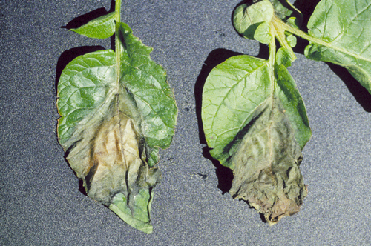

Figure 2.
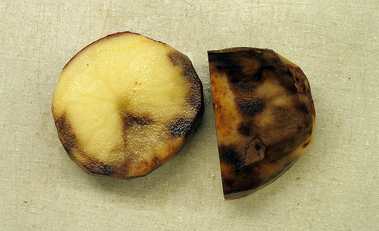

Figure 3.
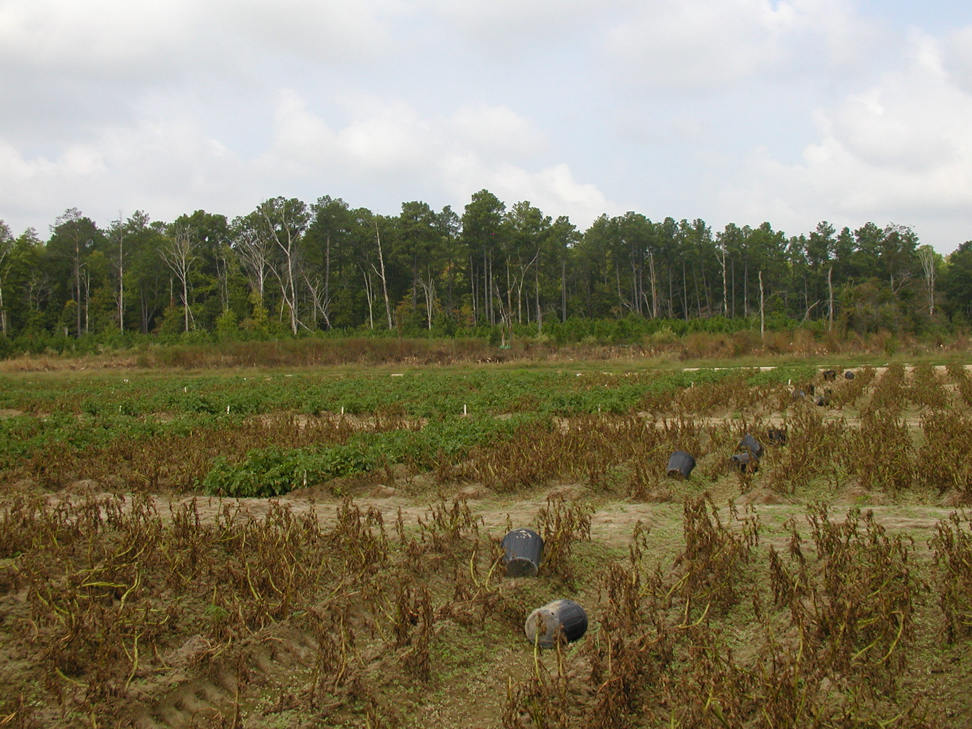

If you have any questions please call: Bill Shockley – 757-414-0738 x 223 or
Steve Rideout 757-414-0724 x 17 or Christine Waldenmaier 757-414-0724 x 40

