Virginia Potato Disease Advisory – 2009
Sponsored by the Virginia Irish Potato Board
May 13 – May 19

This is the fourth Virginia Potato Disease Advisory for 2009. We want to thank the Virginia Irish Potato Board for funding the network of sensors and our weekly reports. Thanks to the VIPB and all the participating producers! It is our goal to make the Advisory more informative this year than in years past by highlighting important potato diseases or pertinent subject matters with each report. See below for a description of damage caused by Rhizoctonia of potato. As always, your feedback is important and welcomed on how to make the VPDA more informative and effective.

Accumulation of Late Blight Disease Severity Values (DSV) and Early Blight P-Days has continued at all locations. See below for fungicide recommendations. The approaching drier weather should prove beneficial for slowing our disease risk down.

Late Blight Prediction: Fungicide applications should be initiated once 18 DSV’s have been accumulated for late blight. The threshold for late blight has been reached at all locations. We are recommending applications of materials containing either chlorothalonil (Bravo, etc.) or mancozeb (Manzate, Penncozeb, Dithane, Gavel, etc.). If you have not made a fungicide application to date, or if that fungicide application occurred 14 days prior to this forecast, it is highly recommended that make an application. Fortunately, late blight has not been reported in the Mid-Atlantic Region to date. See the below information on late blight, if you suspect this disease is present in your fields, please let us know. Since we are at full bloom, many growers like to include a systemic material with their protectants, this practice is recommended to help protect developing tubers. Our past research has shown that applications of Ridomil Gold (MZ, Bravo, or Copper formulations), Quadris (9 oz/A+), and Ranman have been most effective at suppression of tuber diseases.

Early Blight Prediction: We use the program WISDOM to calculate P-Days, fungicide applications targeting early blight should be made when we reach 300 cumulative P-Days. To date, we have only reached this threshold at the Kiptopeke and Seaview locations. Protectant materials applied for late blight control should be sufficient to stave off early blight infections.

Late Blight Disease Severity Values (DSV) accumulated to date:

Location | Total DSV | Spray Recommendation
Horntown | 38 | SPRAY RECOMMENDED
New Church | 47 | SPRAY RECOMMENDED
Painter | 29 | SPRAY RECOMMENDED
Birdsnest | 35 | SPRAY RECOMMENDED
Seaview | 29 | SPRAY RECOMMENDED
Kiptopeke | 32 | SPRAY RECOMMENDED

Early Blight P-Days accumulated to date:
Location | Total P-Days | Spray Recommendation
Horntown | 222 | None Recommended
New Church | 215 | None Recommended
Painter | 247 | None Recommended
Birdsnest | 292 | None Recommended
Seaview | 312 | Spray Recommended
Kiptopeke | 311 | Spray Recommended

Weekly Potato Disease Summary
Rhizoctonia of Potato
Causal Organism: Rhizoctonia of potato is caused by the soilborne fungus Rhizoctonia solani. The fungus can overwinter in the soil on plant debris or on infected tubers. The pathogen can be an issue from planting until harvest. Seed pieces and emerging stolons may be infected by Rhizoctonia prior to emergence. Damping-off can be caused on emerged seedlings under severe infections and favorable conditions. Tubers and stolons can be damaged by the pathogen later in the growing season. Disease is favored by moderate soil temperatures (50 - 70F) with excessive rainfall or irrigation. The fungus can infect and damage most crop plants planted on the Eastern Shore of Virginia, particularly in the seedling stage.

Symptomology: Poor and non-uniform emergence can result from early infections. Infected potato shoots can be girdled at the soil surface and exhibit a sunken blackish lesion (Figure 1). Similar lesions can be found belowground on stolons later in the growing season, this phase of the disease is known as black scurf (Figure 2). Starch and water translocation can be disturbed in these damaged plants. An increase of aerial, green tubers forming at/above the soil surface has been observed in infected plants. Infected tubers show dark brown-black masses that are small in size, these tuber lesions are actually sclerotia of the fungus attacked to the tuber surface (Figure 3). These masses resemble soil particles clinging to the tuber, however, they cannot be removed with washing.

Control: Use certified seed pieces to ensure that you are not transmitting Rhizoctonia. Burying plant debris deep in the soil after harvest will help reduce inoculum in the soil. Crop rotation to corn, cereal or grass crops will help reduce disease levels. Avoid overirrgation and planting in areas that stay wet. Promote timely emergence, the longer the shoots are in the soil the more susceptible they are to this pathogen. The use of an in-furrow application of Quadris or Moncut will reduce early season infections and ensure a quicker emergence. As always, follow pesticide labels for rates and usage. Finally, harvesting tubers in a timely fashion after vine kill will reduce the possibility of further tuber damage.

Figure 1.
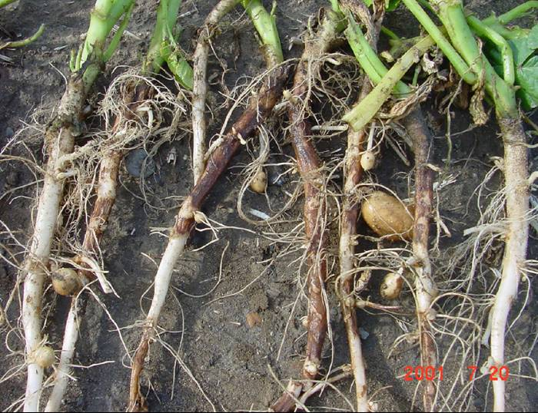

Figure 2.
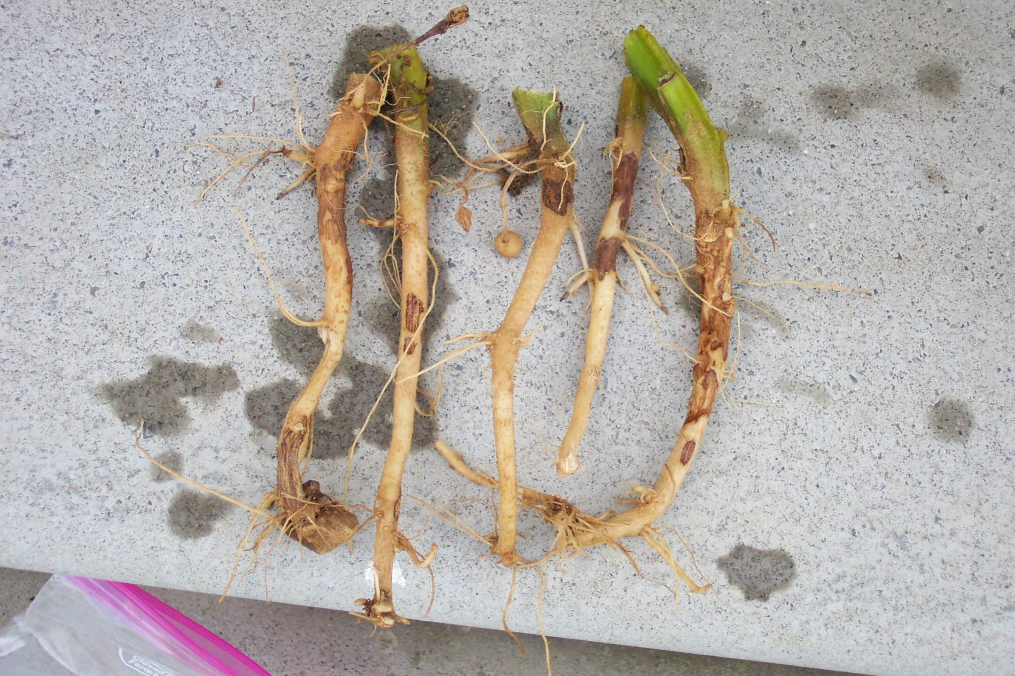

Figure 3.
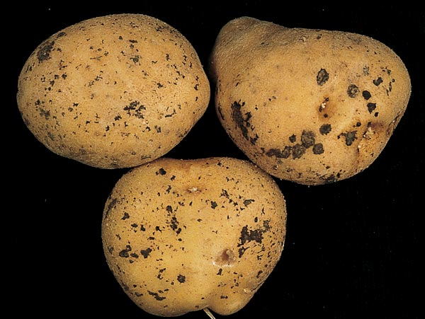

If you have any questions please call: Bill Shockley – 757-414-0738 x 223 or
Steve Rideout 757-414-0724 x 17 or Christine Waldenmaier 757-414-0724 x 40

