Virginia Potato Disease Advisory – 2009
Sponsored by the Virginia Irish Potato Board
April 28 – May 5

This is the second Virginia Potato Disease Advisory for 2009. We want to thank the Virginia Irish Potato Board for funding the network of sensors and our weekly reports. Thanks to the VIPB and all the participating producers! It is our goal to make the Advisory more informative this year than in years past by highlighting important potato diseases or pertinent subject matters with each report. See below for a description of late blight of potato. This is a holdover from last week since we have had a disease trigger for late blight. As always, your feedback is important and welcomed on how to make the VPDA more informative and effective.

This ridiculous rainy weather has led to an accumulation of Late Blight Disease Severity Values (DSV) and Early Blight P-Days. See below for fungicide recommendations.

Late Blight Prediction: Fungicide applications should be initiated once 18 DSV’s have been accumulated for late blight. The threshold for late blight has been reached at the Birdsnest locations. Several other locations are close to threshold values. Since we have had extremely rainy conditions and these have continued since we last read the weather data, I would guess ALL locations will achieve the threshold value if they have not already done so. We are recommending applications of materials containing either chlorothalonil (Bravo, etc.) or mancozeb (Manzate, Penncozeb, Dithane, Gavel, etc.). Fortunately, late blight has not been reported in the Mid-Atlantic Region to date. See the below information on late blight, if you suspect this disease is present in your fields, please let us know.

Early Blight Prediction: We use the program WISDOM to calculate P-Days, fungicide applications targeting early blight should be made when we reach 300 cumulative P-Days. To date, we have not reached this threshold at any location.

Late Blight Disease Severity Values (DSV) accumulated to date:

Location | Total DSV | Spray Recommendation
Horntown | 11 | SPRAY RECOMMENDED
New Church | 11 | SPRAY RECOMMENDED
Painter | 10 | SPRAY RECOMMENDED
Birdsnest | 20 | SPRAY RECOMMENDED
Seaview | 15 | SPRAY RECOMMENDED
Kiptopeke | 17 | SPRAY RECOMMENDED

Early Blight P-Days accumulated to date:
Location | Total P-Days | Spray Recommendation
Horntown | 101 | None Recommended
New Church | 101 | None Recommended
Painter | 124 | None Recommended
Birdsnest | 169 | None Recommended
Seaview | 182 | None Recommended
Kiptopeke | 180 | None Recommended

Weekly Potato Disease Summary
Late Blight of Potato
Causal Organism: Late blight of potato is caused by the airborne fungus (Oomycete) Phytophthora infestans. Late blight of potato is sporadic on the Eastern Shore of Virginia, but can be devastating if conditions favoring the disease persist. Trace amounts of late blight were observed on the Eastern Shore in 2006 and 2008, but the last significant outbreak was in 1996. Disease is favored by moderate temperatures (60-80F) with excessive rainfall or dews leading to high leaf moisture. Also of note, late blight of potato was the disease that caused the Irish Potato Famine in the 1840’s which led to the immigration or death of over 3 million Irish. The late blight pathogen can also parasitize tomatoes.

Symptomology: Infected potato leaves show ‘greasy’ lesions that usually originate from the tip of the leaves (Figure 1). During periods of high moisture gray sporulation can be seen on infected leaves. If infection persists or becomes systemic, tubers may become discolored exhibiting black and greasy lesions (Figure 2). Infected tubers may also transmit the disease to subsequent crops if they are used as seed pieces. In severe infections, complete defoliation can occur if appropriate disease control measures are not employed (Figure 3).

Control: Use certified seed pieces to ensure that you are not transmitting late blight. Prior to disease appearance, growers should utilize a protectant fungicide (ie. chlorothalonil or mancozeb) once sprays are either deemed necessary by the VPDA or if the disease is present within the region. Once the disease is either present on the Eastern Shore or within your fields, systemic fungicides should be used for disease suppression. Systemic fungicides recommended for late blight control include: Curzate, Forum, Gavel, Headline, Omega, Previcur Flex, Quadris, Ranman, Revus Top and Tanos. As always, follow pesticide labels for rates and usage.

Figure 1.
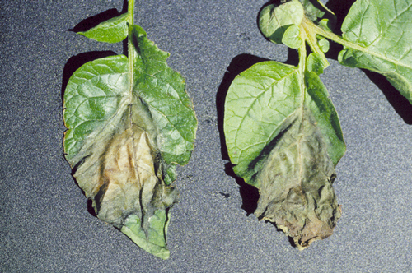

Figure 2.
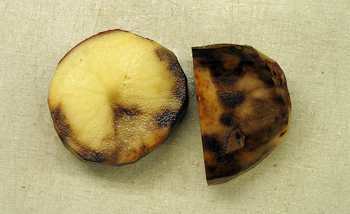

Figure 3.
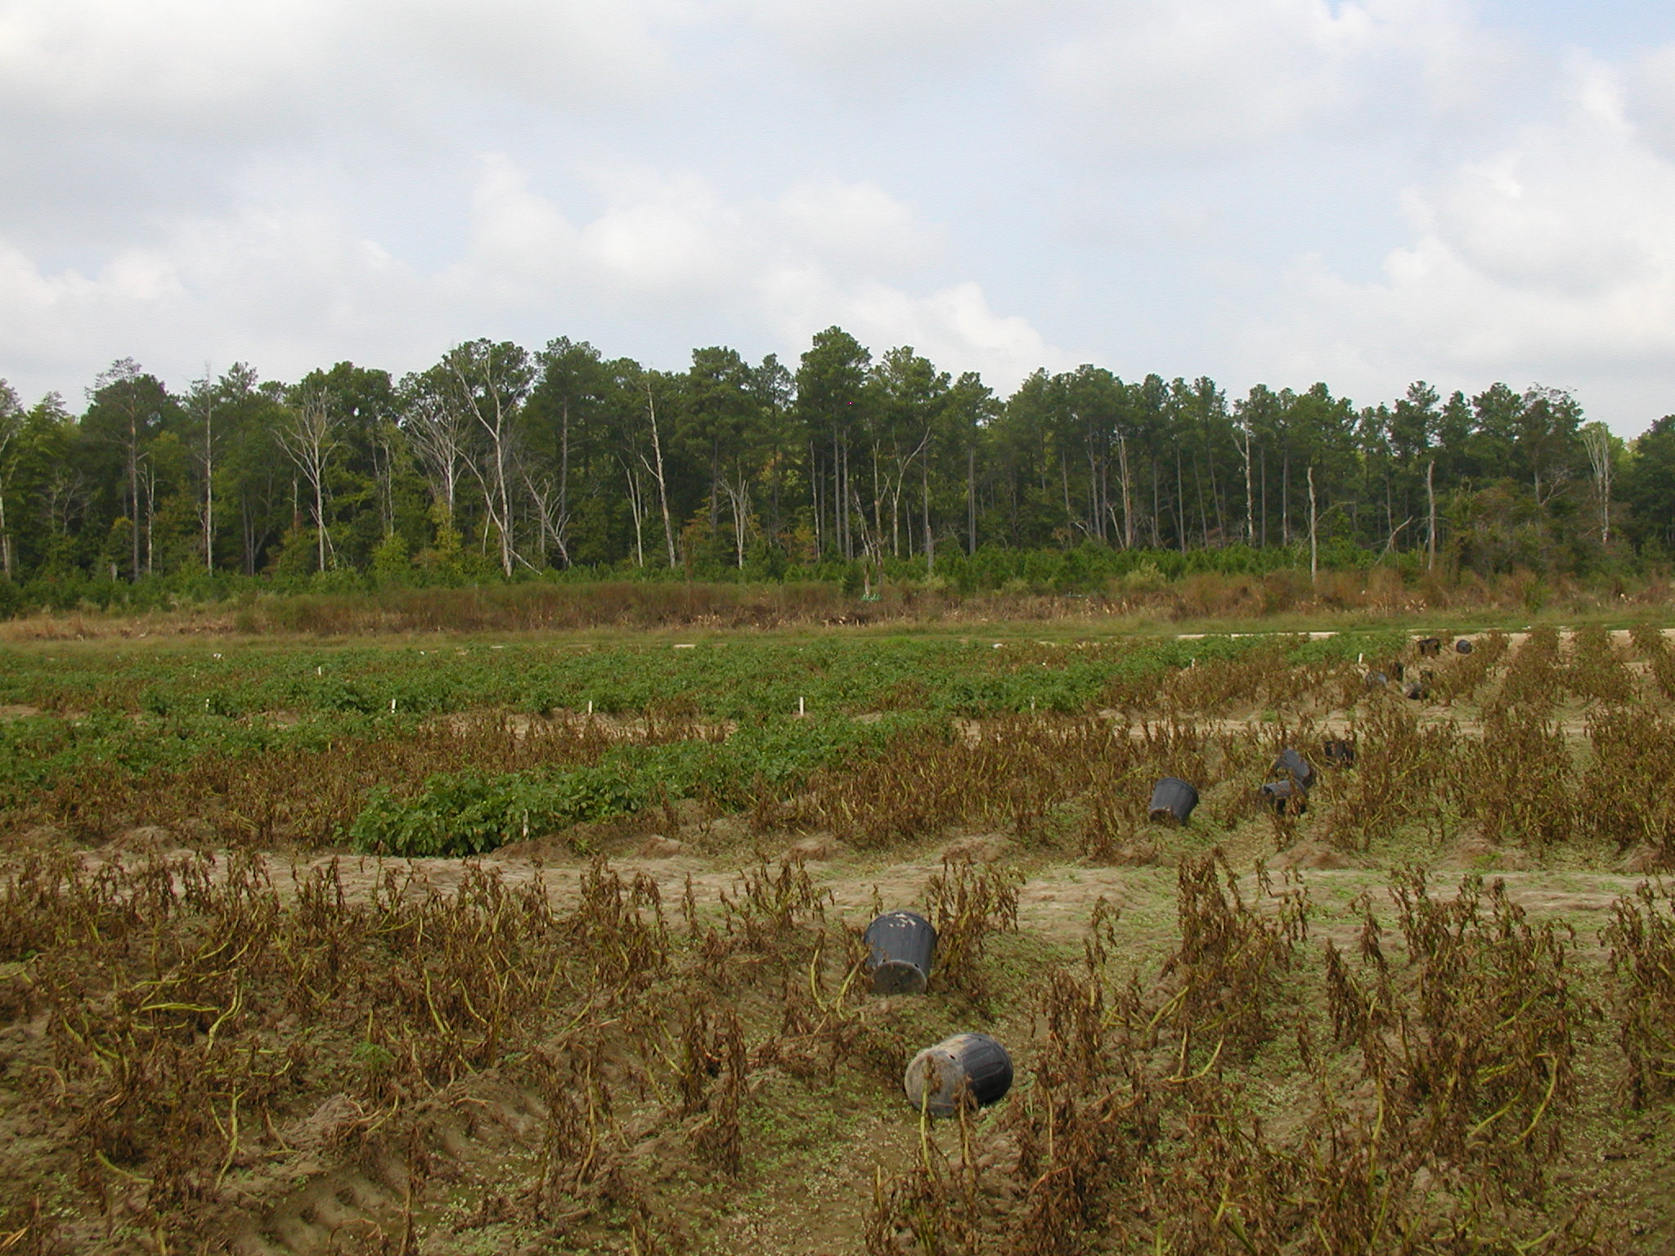

If you have any questions please call: Bill Shockley – 757-414-0738 x 223 or
Steve Rideout 757-414-0724 x 17 or Christine Waldenmaier 757-414-0724 x 40

