EARLY SUMMER
ROW CROPS TOUR:
Insects, Disease, and Agronomics

Thursday, June 6, 2013 – 9:00 AM
Tidewater Ag. Res. & Ext. Ctr.
1045 Hare Road (Research Farm)
Suffolk, VA 23437

CCA-CEU recertification credits are available, please have your CCA number and remember to sign in and sign out at the registration booth.

Private Applicator, Commercial Applicator (categories
1-A, 1-C, and 10) and Registered Technician (category 60) recertification is available.

Lunch will be provided following the field tour, courtesy of Berry Lewis with Bayer CropScience

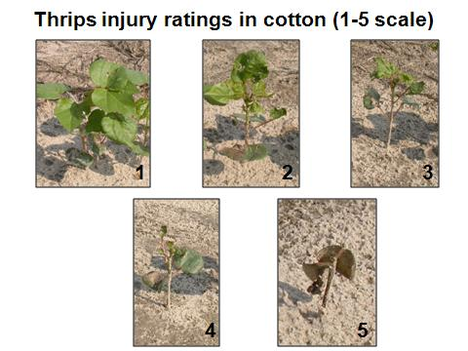
Tour will start promptly at 9:00 am.

TOUR INFORMATION

9:00-9:05 Welcome
Dr. Allen Harper, Director, Virginia Tech Tidewater AREC

9:05-9:20 Introduction
Dr. Ames Herbert, Professor, Entomology

9:25-9:45 Use of genomics and physiology in crop improvement
Dr. Maria Balota, Assistant Professor, PPWS

9:50-10:30 Tour of thrips management cotton/peanut research plots
Dr. Ames Herbert

10:35-10:55 New tools for peanut and cotton disease control
Dr. Pat Phipps, Professor, PPWS

11:00-11:20 Oats as an alternative cover crop
Dr. David Holshouser, Associate Professor, CSES

11:25-11:55 Soil fertility research in Virginia cotton
Dr. Hunter Frame, Assistant Professor (Field Crops Agronomist), & Mr. Austin Brown, M.S. Student

12:00-12:20 Fungicides boost wheat yield
Dr. Pat Phipps

12:25 Announcements
Dr. Allen Harper

12:30 Lunch
Provided by Berry Lewis, Bayer CropScience

1:00-1:30 Legal aspects of pesticide use in Virginia
Robert Christian, Pesticide Investigator, Virginia Dept. of Agriculture and Consumer Services

Map to TAREC Research farm:
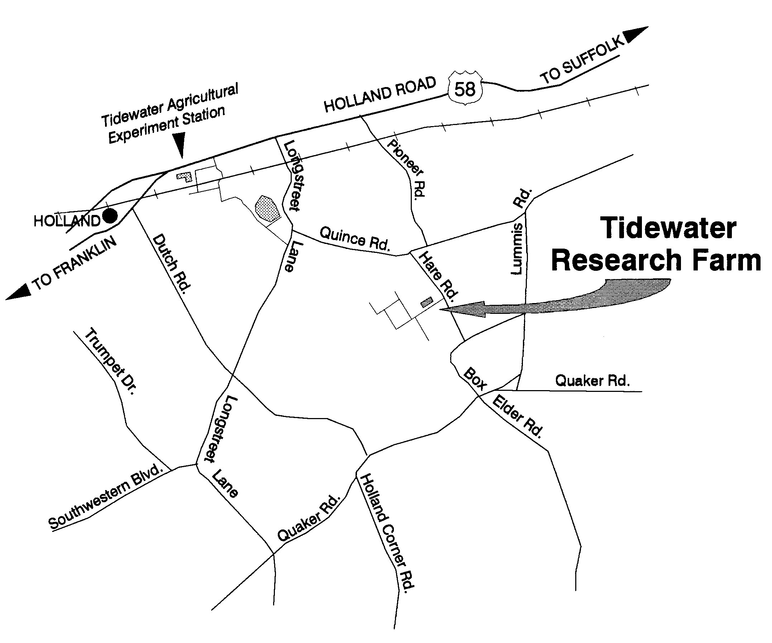

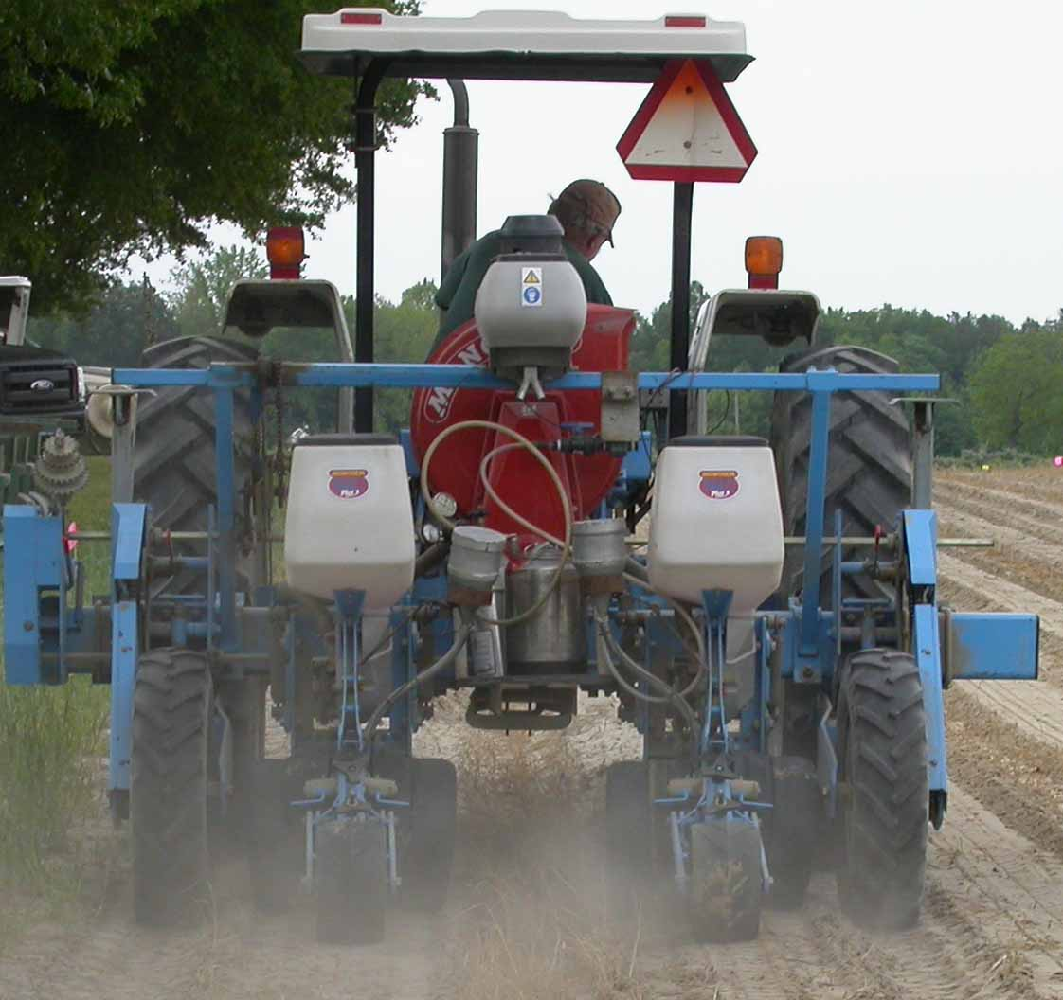

www.ext.vt.edu
Extension is a joint program of Virginia Tech, Virginia State University, the U.S. Department of Agriculture, and state and local governments.

Virginia Cooperative Extension programs and employment are open to all, regardless of race, color, national origin, sex, religion, age, disability, political beliefs, sexual orientation, genetic information, marital, family, or veteran status, or any other basis protected by law. An equal opportunity/affirmative action employer. Issued in furtherance of Cooperative Extension work, Virginia Polytechnic Institute and State University, Virginia State University, and the U.S. Department of Agriculture cooperating. Edwin J. Jones, Director, Virginia Cooperative Extension, Virginia Tech, Blacksburg; Jewel E. Hairston, Administrator, 1890 Extension Program, Virginia State, Petersburg.

Support for these projects was provided, in part, by the following:
Cotton Incorporated
National Peanut Board
North Carolina State University
South Carolina Peanut Growers Association
United Soybean Board
Virginia Agricultural Council
Virginia Cotton Board
Virginia Dept. of Conservation & Recreation
Virginia Peanut Board
Virginia Peanut Growers Association
Virginia Small Grains Board
Virginia Soybean Board
Virginia State Cotton Support Committee
Virginia-Carolina Peanut Association Inc.

Advanta Seeds
AMVAC
BASF Corporation
Bayer CropScience
Birdsong Peanut Company
Chemical Dynamics, Inc.
Cheminova Inc.
Chemtura
Dow AgroSciences LLC
Dyna-Gro
E.I. DuPont de Nemours and Company
Fluid Fertilizer Foundation
FMC Corporation
Hubbard Peanut Company Inc.
Monsanto Company
Murphy-Brown, LLC
Nichino America, Inc.
Pioneer Hi-Bred
Progeny Ag-Golden Acres Genetics
Richardson Seeds, Ltd.
Seed Source Genetics
Sorghum Partners
Stoller USA
Syngenta Crop Protection, Inc.
Truimph Seed
Valent U.S.A. Corporation
Wakefield Peanut Company
Weyerhaeuser Company
Whitehurst and Associates
EARLY SUMMER
ROW CROPS
TOUR

June 6, 2013 – 9:00 am

Tidewater Agricultural Research & Extension Center Research Farm,
1045 Hare Road, Suffolk, VA

Recertification credits for Certified Crop Advisers, Private Applicators, Commercial Applicators (categories 1-A, 1-C, and 10), and Registered Technicians (category 60) are available

