Mid-season sorghum insect pests

Headworms (corn earworm and fall armyworm)
In pre-headed sorghum, worm control is rarely justified, even with ragged shotholes and 40-60% leaf injury. Heads should be sampled soon after flowering until the soft dough stage by scouting a minimum of 200 plants (sample multiple areas). Shake heads into a 5-gallon bucket and count the headworms. Treat only when larvae damage the head or the developing growing point and worms average 2 or more per head. Open-headed hybrids are damaged less than the compact or closed-headed type. Multiple pyrethroid insecticides are labeled for corn earworm control, but methomyl (Lannate) is the best option for fall armyworm.

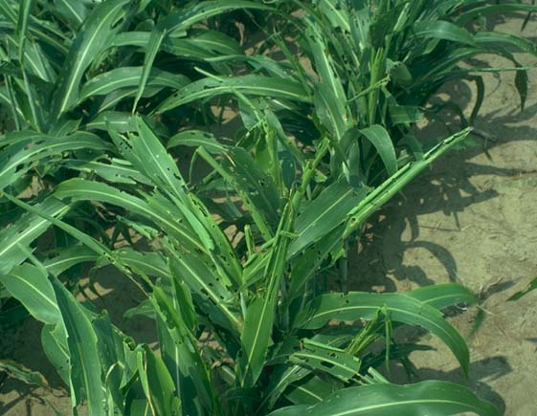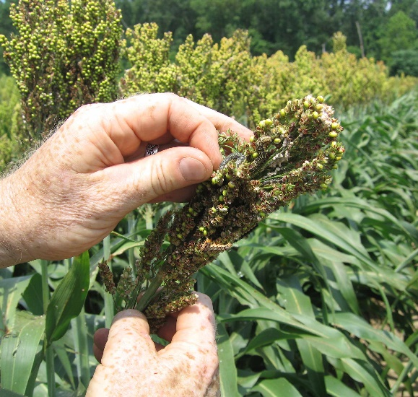
Sorghum leaves with ragged shothole worm injury; headworms (corn earworm) in sorghum.

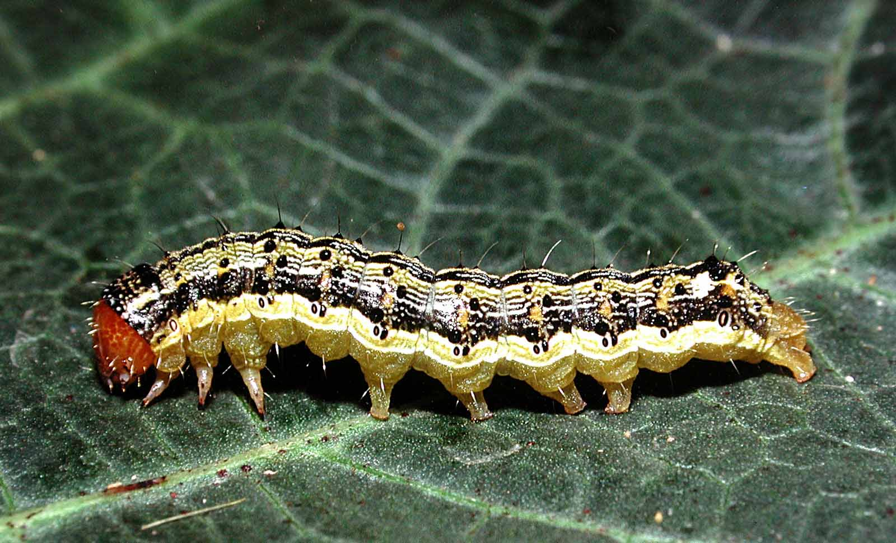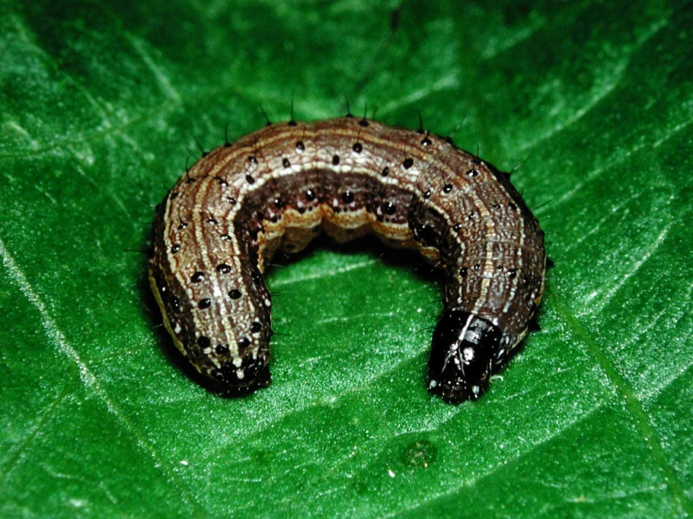
Corn earworm and fall armyworm larvae (both photos courtesy of Martin Spellman).
Aphids
A mixture of aphids may be found in Virginia sorghum fields, including white sugarcane aphid (Melanaphis sacchari), a species that has recently made a host switch from sugarcane to sorghum. It was first discovered in Virginia in September 2015. Infestations of white sugarcane aphid can stunt or even kill sorghum plants that are in the pre-head stage, and after heading the honeydew can interfere with mechanical harvest by plugging up combines.

Another aphid pest of sorghum is the yellow sugarcane aphid (Sipha flava). According to Michael Brewer (Texas A&M University), yellow sugarcane aphid can be a problem on seedling sorghum. Dr. Brewer mentions that he gets concerned when there are 5 yellow sugarcane aphids per leaf on one-leaf sorghum, but if the sorghum is older or growing fast, typically just the base leaf is damaged and everything else is O.K. Lorsban seems to work well for yellows, less so for white sugarcane aphid. Corn leaf aphids (Rhopalosiphum maidis) are rarely worth concern–they are just good food for beneficial natural enemies!

Since white sugarcane aphid was found this season in late July, it is important to scout sorghum at least weekly for this pest. Start with field edges, especially checking the underside of lower leaves. Leaves that are shiny with honeydew are a clue that aphids are present on that plant. A general threshold is 25% of plants infested with white sugarcane aphid colonies. When white sugarcane and other aphid species are in the mix, control decisions should be based on white sugarcane aphid numbers and product recommendations (i.e., Sivanto and Transform). Good coverage is essential, and repeat applications (if needed) should rotate chemistries. Pyrethroids are not effective against white sugarcane aphid and are harmful to natural enemy populations, thus should be avoided for that aphid.

