Bailey planted on May 2nd. It probably requires another 14 to 21 days to optimum maturity
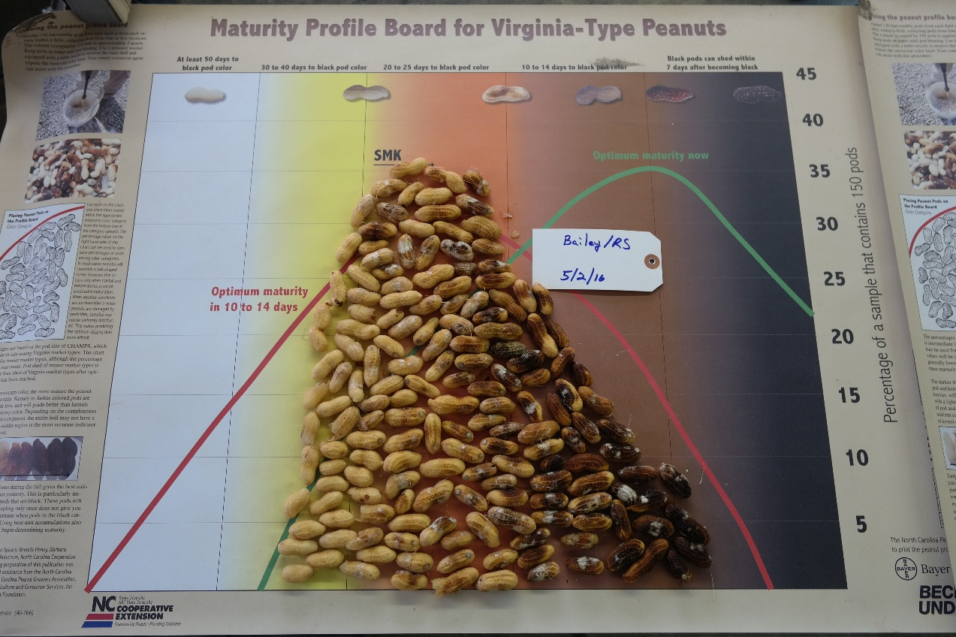
Bailey planted on May 19. It will need at least 3 wks. Before reaching optimum maturity.
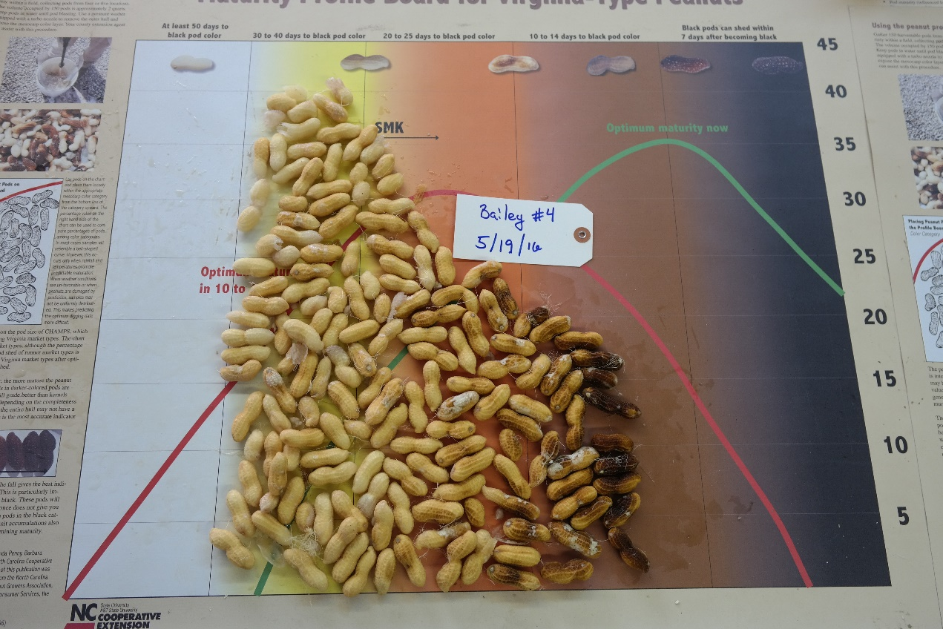

Bailey planted on June 4th. It needs 3 wks. Before reaching optimum maturity.
