Sugg planted on May 19. A little more mature than Bailey, still 3 wks. Before optimum maturity.
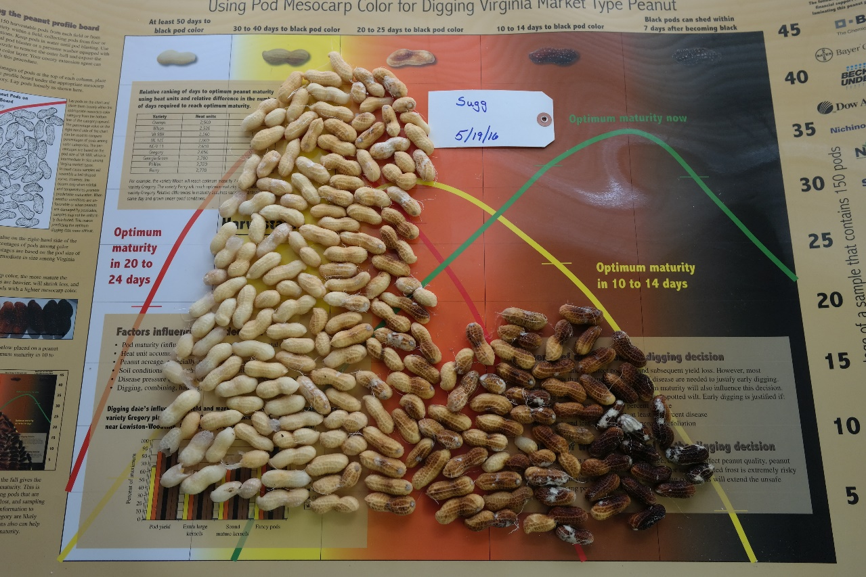

Sullivan planted on June 4th. It seems to be later maturing than Bailey this year.
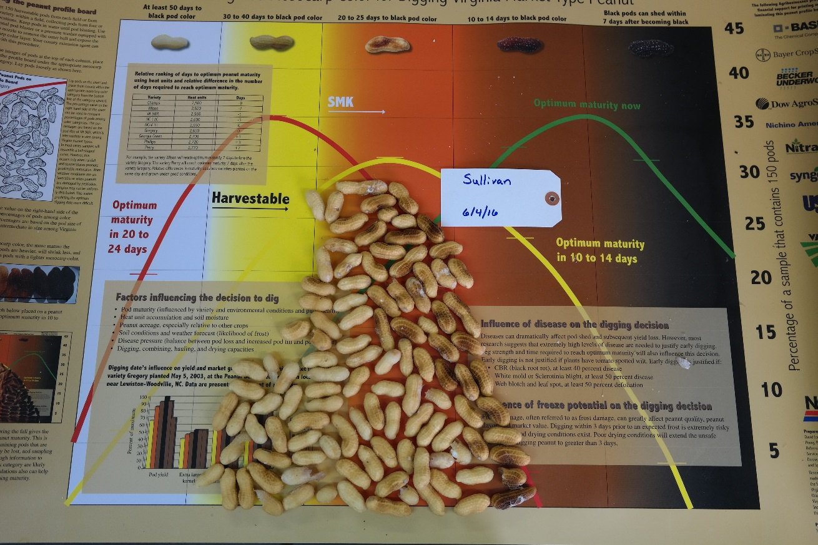
Wynne planted on May 25. Both Sullivan and Wynne will need over 3 wks. To reach optimum maturity this year.
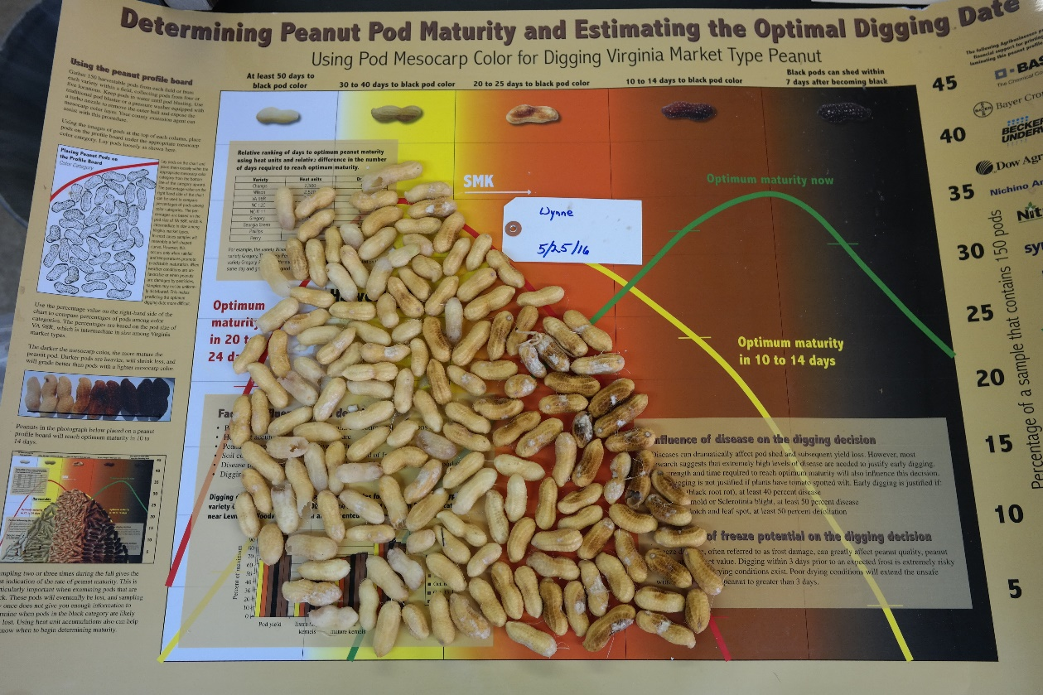
Emery, a 2015 Virginia market-type release, seems to be earlier maturing than Bailey, Sullivan, and Wynne.
